Current Volunteers  In-Office Volunteers – 30  Church Ministry Volunteers – 79  *Total Volunteers in 2019 – 109  Volunteer hours donated – 3,597  Partner Churches  Weiser Christian Church Riverside Baptist Church  Weiser Church of the Nazarene Church of the Redeemer  Weiser Community Church Calvary Baptist Church  Cornerstone Assembly of God Weiser Worship Center  Weiser Church of Christ St. Agnes Catholic Church  Midvale Church of Christ Weiser First Baptist Church  St. Luke’s Episcopal Church Concordia Lutheran Church  Midvale Community Baptist Cambridge Assembly of God  Leadership  Board of Directors: Staff:  John Wootton – Board Chair Pamela Burris – Executive Director  Kevin Hooper – Vice Chair Judy Craft – Clearinghouse Coordinator  Stacy Haines – Secretary Barbara Lee – Operations Manager  Gail Hogg – Treasurer Bonnie Butera - Receptionist  Charlie Friedly  Kelly Haun  Hunter Mizar  Julia Nash  Glen Reeves  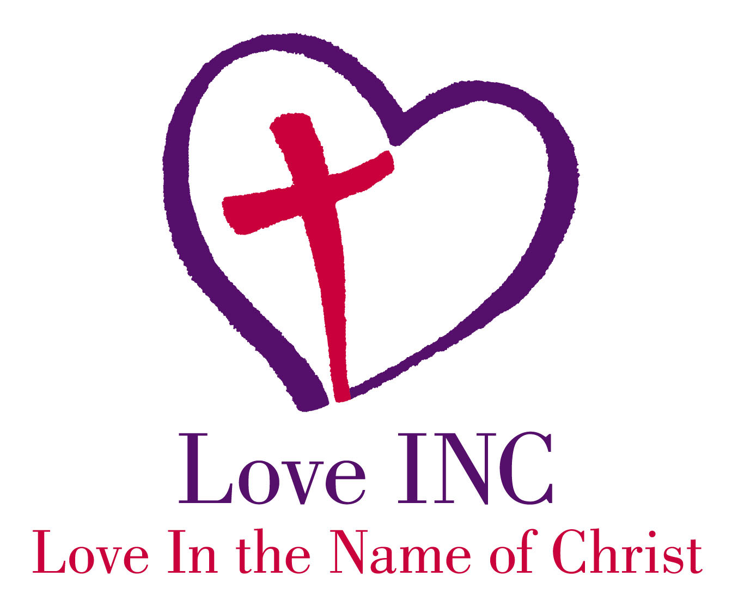 Love INC Washington County PO BOX 348 Weiser, ID 83672 |  |  | Love in the  Name of Christ  Washington County  2019  Annual Report  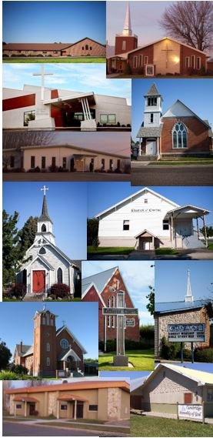

People Served in 2019  Neighbors Served  Families Served - 716  New Families in 2019 – 65  Individual Needs Met – 6,876  Referrals to other agencies - 140  Requests Filled (approximated values)  $1,643  $3,300  $4,795  $1,053  $23,868  $4,698  $10,140  $3,420  $19,662  $4,176  $825  $1,065  $748  - Bedding – 53  - Household Cleaning Supplies – 44  - Coats – 223  - Clothing Vouchers – 27  - Food Boxes – 459  - Thanksgiving Meal Boxes – 54  - Furniture – 78  - Personal Hygiene Kits – 90  - Backpacks/School Supplies – 226  - Housewares – 48  - Medical Equipment – 11  - Gas Cards – 71  - Special Requests – 23  Non-Material Services  - Home Visits/Food Deliveries – 171  - Rides/Transportation provided to - 11  - Enrichment Classes – 15 families average/month  - Celebrate Recovery – many shared clients  - Prayer & Relational Support – every client is prayed with and for – building relationships is key! |  |  | 2019 Financials  Cash Contributions  From Churches $11,155  2019 Gala $22,308  Monthly Donors $24,899  Other Gifts from individuals $31,481  Total Cash Contributions $89,843  Expenses by Category  $44,821  $5,028  $15,224  $1,512  $3,939 $3,628 $1,754  $12,530  $1,761  $3,401 $93,599*  Wages & Payroll Expenses for 4 employees  Occupancy (utilities, property tax, etc.)  Building Maintenance & Improvement  Liability Insurance  Fundraising Costs  Training  Affiliate Dues/Membership Fees  Material Goods Purchased for Clients  Community Outreach  Other (office supplies, equipment, etc.)  Total Expenses 2019  *$6,498 for client expenses donated in 2018 was disbursed in 2019. Actual expenses were not greater than income.  Non-Cash Contributions  $79,393  $14,700  $91,472  $3,050 $188,615  Material Goods Donated  Rent on 2 Buildings  Volunteer Hours  Donated Professional Services  Total Non-Cash Contributions  For every $1 donated we do $3.10 worth of ministry!

