|  |  |  |  |  |  |  |  |  |  |  |  |
| --- | --- | --- | --- | --- | --- | --- | --- | --- | --- | --- | --- |
| |  | | --- | | Current Volunteers In-Office Volunteers – 34  Church Ministry Volunteers – 79  *Total Volunteers in 2018 - 113 Partner Churches Weiser Christian Church Riverside Baptist Church  Weiser Church of the Nazarene Church of the Redeemer  Weiser Community Church Calvary Baptist Church  Cornerstone Assembly of God Weiser Worship Center  Liberty Street Church of Christ St. Agnes Catholic Church  Midvale Church of Christ Weiser 1st Baptist Church  St. Luke’s Episcopal Church Concordia Lutheran Church  Midvale Community Baptist Cambridge Assembly of God Leadership Board of Directors: Staff:  Hunter Mizar – Board Chair Pamela Burris – Executive Director  John Wootton – Vice Chair Elise Walker – Clearinghouse Coordinator  Glen Reeves – Secretary Judy Craft – Clearinghouse Coordinator  Gail Hogg – Treasurer Barbara Lee – Operations Manager  Charlie Friedly Bonnie Butera - Receptionist  Stacy Haines  Kelly Haun  Kevin Hooper | | |  |  | | --- | --- | |  | Love INC Washington County PO BOX 348 Weiser, ID 83672 | | |  |  | |  | | --- | | Love in the  Name of Christ  Washington County  10 Year Celebration 2009-2019  Annual Report | | |  | | --- | |  | | | Love INC Washington County  [Subtitle] | |

|  |  |  |  |
| --- | --- | --- | --- |
| People Served in 2018 Volunteers Adult’s Needs Met – 1,316  Children’s Needs Met – 948  New Families in 2018 – 99  **Requests Filled** (approximated values)   * Bedding – 48 $1,920 * Household Cleaning Supplies – 20 $1,100 * Coats – 113 $2,373 * Clothing Vouchers – 39 $1,365 * Food Boxes – 369 $26,568 * Thanksgiving Meal Boxes – 53 $4,505 * Furniture – 40 $5,120 * Personal Hygiene Kits – 54 $1,998 * Backpacks/School Supplies – 129 $10,965 * Housewares – 12 $1,020 * Medical Equipment – 17 $1,445 * Gas Cards – 45 $788 * Special Requests – 18 $1,350   **Non-Material Services**   * Home Visits/Food Deliveries – 166 * Enrichment Classes – 15 families average/month * Celebrate Recovery – many shared clients * WACHAT – 118 people enrolled * Prayer & Relational Support – every client is prayed with and for – building relationships is key! |  |  | 2018 FinancialsCash Contributions From Churches $12,170  2018 Gala $24,405  Monthly Donors $19,124  Other Gifts from individuals $10,468  **Total Cash Contributions $66,167** Expenses by Category Wages& Payroll Expenses for 4 employees $36,504  Occupancy (utilities, property tax, etc.) $5,083  Building Maintenance & Improvement $7,286  Liability Insurance $1,467  Fundraising $3,513  Training $3,424  Affiliate Dues/Membership Fees $973  Material Goods Purchased for Clients $4,581  Community Outreach $1,082  Other (office supplies, equipment, etc.) $4,424  **Total Expenses 2018 $68,337** Non-Cash Contributions Material Goods Donated $55,936  Rent on 2 Buildings $7,236  Volunteer Hours $56,244  Donated Services $3,500  **Total Non-Cash Contributions $122,916**  For every $1 donated we do $2.86 worth of ministry! |
|  |  |  |  |

|  |  |  |
| --- | --- | --- |
|  |  |  |

We have been blessed with so many wonderful volunteers over the past 10 years who have selflessly given their time, emotional & physical energy and shared their faith with our neighbors in need. When a volunteer passes on, we are left with great joy because we know they hear from our Lord, “Well done, my good and faithful servant.” But we also have a hole in our hearts because every volunteer is our family!

**Beloved Volunteers who have Passed on**

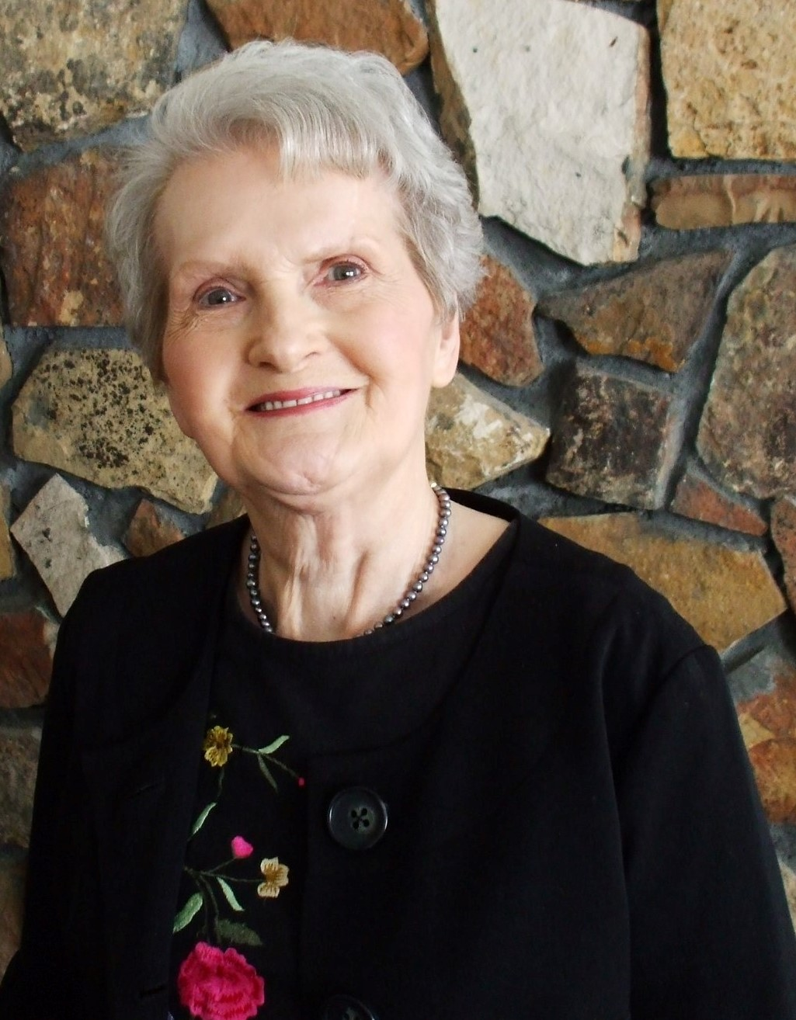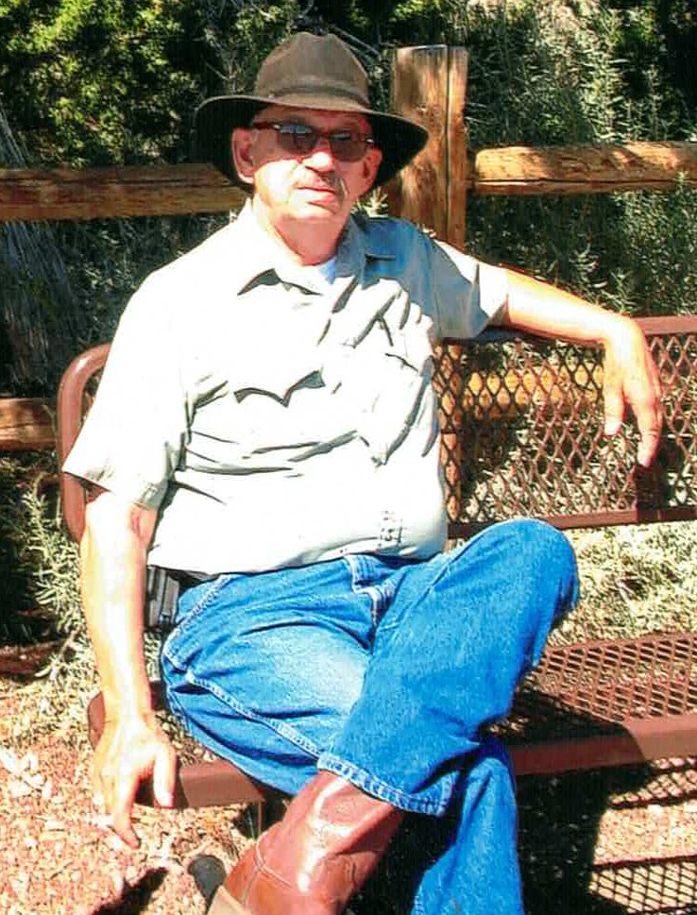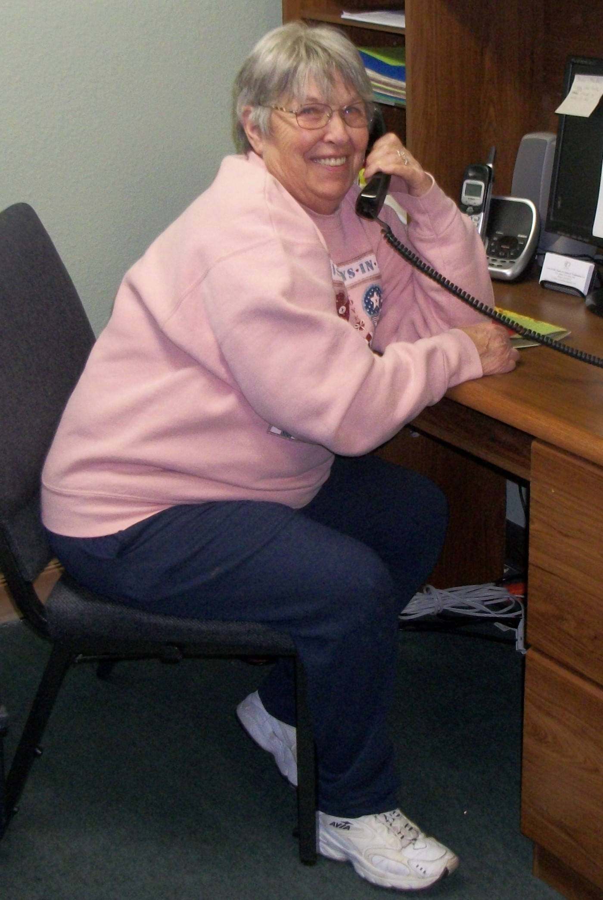

**Genevieve James** – receptionist & food pantry

**Terry Lee** – Celebrate Recovery, Jail ministry, chief Go-fer

**Jean Liles** - receptionist & food pantry

**Lerlene Dove** (not pictured) – receptionist & coupon ministry

**Dolores VanAuken** (not pictured) – receptionist & food pantry

**Beloved Volunteers who have Passed on**



**Genevieve James** – receptionist & food pantry

**Terry Lee** – Celebrate Recovery, Jail ministry, chief Go-fer

**Jean Liles** - receptionist & food pantry

**Lerlene Dove** (not pictured)– receptionist & coupon ministry

**Dolores VanAuken** (not pictured) – receptionist & food pantry

**Honoring Our Beginnings**

**Original Development Committee February 2009**

**(the vision carriers)**

**for Love INC Washington County:**

Charles Winegardener (Chair)

Rose Alcorn

Tharesa Little

Dennis Cooper

Sandy Cooper

Pastor Steve Penner

Dr. Suzanna Hubele

Elise Walker (Treasurer)

Pastor Bill Gartung

**Original Elected Board of Directors:**

Sandra Cooper (Chair)

Rose Alcorn (Vice Chair)

Jo Honey-Hardenbrook (Secretary)

Randy Hibberd (Treasurer)

Lorene Pope

Gail Hogg

Brenda Lukehart-Mattson

Kim Hamilton

Tharesa Little

Jack Wiley

**First Hired Executive Director:**

Tharesa Little

**First (Volunteer) Clearinghouse Coordinator:**

Elise Walker

We received our official recognition as a fully open, operating

affiliate in November of 2009

**Honoring Our Beginnings**

**Original Development Committee February 2009**

**(the vision carriers)**

**for Love INC Washington County:**

Charles Winegardener (Chair)

Rose Alcorn

Tharesa Little

Dennis Cooper

Sandy Cooper

Pastor Steve Penner

Dr. Suzanna Hubele

Elise Walker (Treasurer)

Pastor Bill Gartung

**Original Elected Board of Directors:**

Sandra Cooper (Chair)

Rose Alcorn (Vice Chair)

Jo Honey-Hardenbrook (Secretary)

Randy Hibberd (Treasurer)

Lorene Pope

Gail Hogg

Brenda Lukehart-Mattson

Kim Hamilton

Tharesa Little

Jack Wiley

**First Hired Executive Director:**

Tharesa Little

**First (Volunteer) Clearinghouse Coordinator:**

Elise Walker

We received our official recognition as a fully open, operating

affiliate in November of 2009